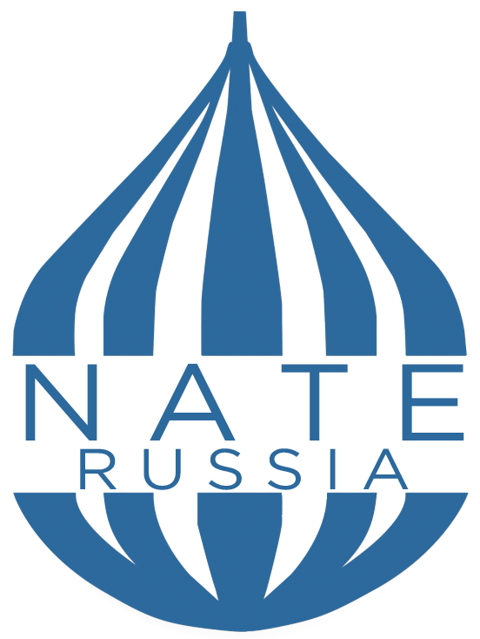

Dear colleagues,

The National Association of Teachers of English (NATE Russia) and ITMO University, supported by the English Language Office at U.S. Embassy in Moscow, are pleased to invite you for the XXVth NATE Jubilee Convention and English Language Expo: 25 Years of Navigating Through Challenges.
The Conference will be held in St. Petersburg on April 17-19, 2019.
During the conference participants will review the last 25 years of NATE and its role in the development and sharing of best practices and know-how in the sphere of English language teaching.
This year’s Conference main topics are:
- NATE Russia projects
- CLIL, CBI & EMI: challenges and achievements
- ESP & EAP
- Teaching Soft Skills in the context of EL curriculum
- Teaching Russian as a foreign language
- Enhancement of EL level through extracurricular activities at school
- EL level assessment (OGE, EGE, Cambridge exams, TOEFL)
- Current trends in applied linguistics
Call for proposals is open now. Russian and international experts are encouraged to participate in the following formats:
- Workshop (45 mins)
- Plenary speech (30 mins)
- Scientific publication
- Poster presentation
- Presentation for one of the Special Interest Group sessions (15 mins)
Proposals in English are to be submitted through the electronic form on the website of the Conference till February 15, 2019.
Travel and accommodation expenses of speakers from other cities may be covered. All attendees and presenters will receive Certificates.
Registration for participants will be open from January 28th till April 1st. Registration fee is 1500 RUB, and 999 RUB for NATE members. The fee covers participation in the sessions, workshops and coffee breaks during the Conference, welcome pack, certificate of attendance, participation in the lottery, and Conference proceedings book for the authors.
On April 20th the Post-Conference event devoted to Professional Development of the specialists in the sphere of EL teaching will be held. Participation should be paid separately.

Venue: ITMO University, 49, Kronverksky pr., St. Petersburg
Proposal submission and registration: nateconf.ru
Email: nateconf2019@corp.ifmo.ru
NATE membership questions: secretarynate@gmail.com, www.nate-russia.ru

2019 NATE Russia Convention and English Language Expo

Preliminary Conference Program:

April 13-16, 2019 Pre-NATE 2019*
10.00-18.00 | Young Teacher School “NATE Informal 2019”
April 16, 2019
13.00-16.00 | Optional excursion around the city*, visit to Optics museum
16.00-18.00 | Preliminary registration
April 17, 2019 Day 1
09.00-10.00 | Registration
10.00-12.00 | Opening plenaries
12.00-12.30 | Coffee break
12.30-14.00 | Panel discussion
14.00-15.00 | Lunch
15.00-17.00 | Concurrent workshops
18.30-20.30 | Reception
April 18, 2019 Day 2
09.00-11.30 | Plenaries and discussion
11.30-12.00 | Coffee break
12.00-13.00 | Concurrent workshops
13.00-14.00 | Lunch
14.00-15.30 | NATE members meeting
15.45-19.00 | Special Interest Groups sessions
April 19, 2019 Day 3
09.00-12.00 | Plenaries and discussion
12.00-12.30 | Coffee break
12.30-14.00 | Closing plenaries
14.00-15.00 | Lunch
April 20, 2019 Post-conference event*
10.00-17.00 | Professional Development sessions
* Participation in these events should be paid separately

